# CSSE2310: 2013 ‘Practice’ exam answers

## [UQAttic](http://uqattic.net)

## Get more out of your study time. Join UQAttic's revision chat.

#### [**Other exam papers**](https://docs.google.com/folder/d/0B6_D4T6LJ-uwYzY1YWMzNjYtMzUyZC00OTEyLWJlMjktOGExYWUwOTc4NDE3/edit)

### Please contribute to these documents.

### If you're looking for an effective way to familiarise yourself with the course material, you can't go past collaborating with fellow students. We have laboured to put these up, and so at the very least point out where you think we are wrong!

### You'll get more out of the course, you'll do better in the exam, and other students will benefit from your input as well.

### To get editing permissions, simply go to the [chatroom](http://uqattic.net) and provide us with your Google Account address.

### Style.

### Type answers in blue beneath each question.

### If you're unsure of your answer, highlight your answer text then hit Ctrl+Alt+M to create a comment beside the text. Once you're satisfied with the answer, click the "Resolve" button on the comment.

### If you want some extra explanation from someone else on their answer, highlight the other person's answer and repeat the procedure above.

### Communicate.

### Head over to [uqattic.net](http://uqattic.net/) and click "Chat Now!". You'll find a chatroom full of students just like you. Talk about a revision document (like this one) or swap prep tips. If you have your own IRC client, point it to irc.uqattic.net, port 6667, channel #attic.

**Q1) Write shell commands to do the following:**

**A) Delete all files with names beginning with A and ending in .c**

rm A*.c

**B) Show all lines in the file stuff which start with W**

grep ^W stuff

**C) A file nums consists of 4 space separated columns. Output columns 1, 3, 4 sorted by the last column**

cut -d ‘ ‘ -f1,3,4 nums | sort -k 3

OR

sort -k 4 nums | cut -d’ ‘ -f1,3,4

OR

cat nums | cut -d’ ‘ -f1,3,4 | sort -k 3

**D) Create a file c.c which is a copy of b.c**

cp b.c c.c

**E) For files f1, f2, f3, show all lines from any of them which contains all the words “song”, “river” and “terrible”**

cat f1 f2 f3 | grep song | grep river | grep terrible

**Q2) Write C to declare foo as:**

**A) An array of 12 integers**

int foo[12];

**B) A pointer to a positive integer**

unsigned int* foo;

**C) Another name for a small integer**

typedef short foo;

**D) A struct containing an integer called i and a string called s**

struct {

int i;

char* s;

} foo;

**NOTE: As question says a ‘struct’, it should be an instance of a struct, so foo goes at the end.**

**E) A pointer to a function which takes two floating point values and returns a string**

char* (*foo)(float, float);

**Q3)**



**A.** 2

**B.** 4 7

**C.** 3 6

**D.** 17

**E.** 9

**F.** 4 6

**G.** 8 2

**H.** 28

**I.** 8 9

**J.** 4 3 3 5

**K.** w ld

**Q4) A system has 32bit virtual address, 4KB pages and page table entries are 4Bytes. It uses a two level page table.**

**A. Which pages do the following (decimal) addresses belong to?**

**11111, 22222, 9001, 404040**

2, 5, 2, 98

Eg.

4096 bytes in a page

Page = virtual address / page size

Page = 11111/4096 = 2.7

This means virtual address 11111 is on Page 2 (which is the third page, since numbering starts at 0).

**B. what causes page faults?**

When an object/process/program is on disk and not in memory.

**C. What causes segmentation faults?**

-trying to access an invalid memory page

-writing to a read only page

**Q5) Consider the following directory listing:**

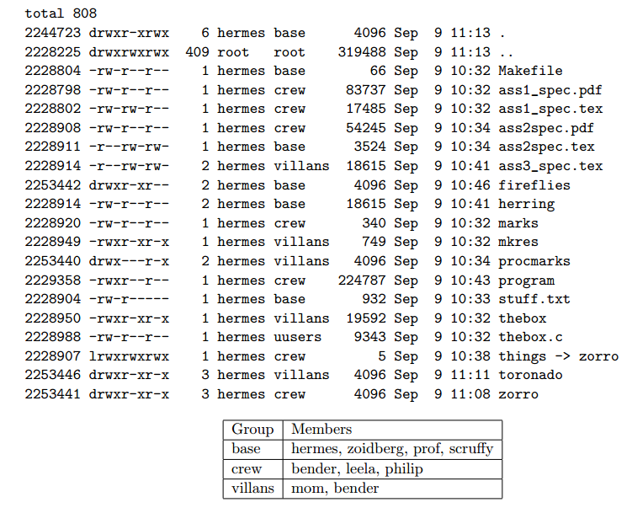

**A) what can zoidberg do to the following:**

**>stuff.txt**

read

**>procmarks**

read, execute

**B) Which users can modify all of the .tex files (without changing permissions)?**

the crew (bender, leela, philip)

**C)What command(s) could mom type to execute program?**

Copy program to home directory and then run it (mom can read program)

cp program ~/program

~/program

**D) What would change in the directory listing after hermes executed rmdir toronado (and why?)**

No change, since toronado is not an empty directory. rmdir does nothing.

**E) What command was used to create things?**

ln -s zorro things

**F) Given the following commands and their output:**

**prompt> ls -l zorro/transport**

**lrwxrwxrwx 1 hermes base 21 Sep 9 11:20 zorro/transport -> ../fireflies/serenity**

**prompt> ls -l fireflies/serenity**

**-rwx--x--x 1 hermes base 1072966 Sep 9 10:46 fireflies/serenity**

**Can bender run ./things/transport ? (Why?)**

No because the fireflies directory doesn’t give bender permissions to execute it (in other words access stuff in the folder)

**Q6) Network stuff**

**A)**

|  |  |  |  |
| --- | --- | --- | --- |
|  | **Network Address** | **Subnet Mask** | **Broadcast Address** |
| **X1** | 10.10.96.0 | 255.255.254.0 | 10.10.97.255 |
| **X3** | 10.10.144.0 | 255.255.248.0 | 10.10.151.255 |
| **X4** | 10.11.64.32  ~~10.11.64.40.0~~ | 255.255.255.240  ~~Shouldn’t this be 255.255.252 since only the last three bits differ?~~ | 10.11.64.47  ~~10.11.64.40.3~~ |

**B) What does the bind() function perform?**

bind(): After a socket has been created, it attaches a local address to it.

**C) X2 performs NAT for this network. What is NAT and why is it necessary?**

Network address translation: Needed when the number of IPs assigned to you is less than the total number of computers trying to access the internet. It assigns an entity/organisation a single IP

Wouldn’t a safer answer be that some IPs are non -routable (<http://jeff.nieusma.com/docs/network/non-routable-ip.html>). If any machines with these IPs want to communicate with the rest of the internet, their address must be converted by the NAT.

**D) to which layers do the following belong:**

|  |  |
| --- | --- |
| **Term** | **Layer** |
| **MAC address** | link |
| **socket** | application <- should this be transport? (Yes, this is transport not application) |
| **IP Address** | network |
| **port** | transport |
| **UDP** | transport |
| **URL** | application |

**E) What is the purpose of a network gateway?**

Router interface connected to the local network. It’s purpose is to send packets out of and receive to the local network.

Isn’t the actual question **E) What is the purpose of a gateway address?**? Would that be the same answer? Or just to receive packets from the local network and send them outward, since the gateway address is technically only the internal-facing interface?

**Q7) Consider a “unix" filesystem where:**

**>i-nodes have 10-direct pointers, 1 indirect pointer and 1 double indirect pointer.**

**>Blocks are 8KB**

**>Block pointers are 4Bytes**

**>blocks are numbered from 0.**

**A)Why is fragmentation a problem for linked filesystems but not for indexed filesystems?**

Indexed filesystems are sequential so adjacent blocks store data “in order”. Linked filesystems hold pointers to data, so the data can be spread (physically) across the disk.

**B) How many blocks (in total) must be accessed to read the following blocks from a file: 9, 2053, 2057**

1 for 9, 2 for 2053, and 1 for 2057 (the pointer is stored from the 2053 read)

total of 4

**C)What is the maximum possible file size for this file system?**

total size = (10*8192) + (1*2048*8192) + (1*2048^2 * 8192) = 33,570,896 kB

**D) If an additional 2 double indirect pointers were added to the i-nodes on this system, what would be the increase in maximum file size?**

Increase is 2*2048^2 * 8192 = 67,108,864 kB

**Question 8: multiprocess/fork stuff**

**A)**

**Lower diagram shows a process being reaped by a process who isn’t its parent (or init). This is impossible.**

**B)**

**~~wait(), with WNOHANG set.~~**

**waitpid();**

**C)**

**kill(pid_t pid, int sig)**

**D)**

**pthread_exit(void* value_ptr)**

**pthread_join(pthread_t thread, void** value_ptr)**

**E)**

**pthread_mutex_lock**

**pthread_mutex_unlock**

**F)**

**~~The down arrow indicates reaping of the child. So the top left, top right and bottom right are possible but not bottom left, for the same reason as (A).~~**

**JEA: Down arrow indicates a thread being joined. All of them are possible. Threads do not follow the same rules as processes, because they are different.**

**Isn’t it that a thread cannot join a thread who isn’t its child? So the bottom left is not correct**

**Threads can join any other thread if they know the thread id.**

**Question 9) code**

**Note: As the question states, the #includes aren’t necessary in your answer. I put them in so I could run the code. Copy/Paste all 5 functions and play around with it for fun.**

#include <stdio.h>

#include <stdlib.h>

#include <string.h>

#include <stdbool.h>

#include <unistd.h>

#include <sys/types.h>

#include <sys/wait.h>

bool matchingLines(const char* string, const char* filename) {

FILE *file;

char line[81];

if ((file = fopen(filename, "r")) == NULL) {

return false;

}

while(fgets(line, 81, file) != NULL) {

if (strstr(line, string) != NULL) {

printf("%s", line);

}

}

return true;

}

**B)**

bool grepSearch(const char* string, const char* filename) {

if (fork()) { /* Parent */

int status;

wait(&status);

··········

if (WIFEXITED(status)) {

if (WEXITSTATUS(status) == 2) {

return false;

} else {

return true;

}

}

} else { /* Child */

execlp("grep", "grep", string, filename, NULL);

exit(0);

}

return true;

}

**C)**

bool matchingLinesMany(const char* string, const char** filenames, int numfiles) {

int i = 0;

int status;

bool result = true;

for(i = 0; i < numfiles; i++) {

if (fork() == 0) {/* Child */

if (matchingLines(string, filenames[i])) {

exit(0);

} else {

exit(2);

}

}

}

for(i = 0; i < numfiles; i++) {

wait(&status);

if (WIFEXITED(status)) {

if (WEXITSTATUS(status) == 2) {

result = false;

}

}

}

return result;

}

With threads (see next page):

struct SearchData {

char *string;

char *filename;

};

void* match(void* arg) {

struct SearchData* data = (struct SearchData*) arg;

bool res = matchingLines(data->string, data->filename);

pthread_exit((void*) res);

}

bool matchingLinesMany(const char* string, const char** filenames, int numfiles) {

pthread_t* threads = malloc(numfiles * sizeof(pthread_t));

struct SearchData* searches = malloc(numfiles * sizeof(SearchData));

bool result = true;

for (int i = 0; i < numfiles; ++i) {

searches[i] = malloc(sizeof(struct SearchData));

data->string = string;

data->filename = filenames[i];

pthread_create(&threads[i], NULL, match, (void*) data);

}

for (int i = 0; i < numfiles; ++i) {

bool res;

pthread_join(threads[i], (void**) &res);

if (!res) {

result = false;

}

free(threads[i]);

free(searches[i]);

}

return result;

}

**D)**

bool grepSearchMany(const char* string, const char** filenames, int numfiles) {

int i = 0;

int status;

bool result = true;

for(i = 0; i < numfiles; i++) {

if (fork() == 0) { /* Child */

execlp("grep", "grep", string, filenames[i], NULL);

//should this line not be

result = grepsearch(string, filenames[i]);

exit(result);

exit(0);

}

}

for(i = 0; i < numfiles; i++) {

wait(&status);

if (WIFEXITED(status)) {

if (WEXITSTATUS(status) == 2) {

result = false;

}

}

}

return result;

}

**E)**

int main(int argc, const char **argv) {

if (argc < 4 || ((strcmp(argv[1], "M") != 0) &&

(strcmp(argv[1], "G") != 0))) {

fprintf(stderr, "Bad params.\n");

exit(1);

}

int i = 0;

int (*func)(char*, char*, int); // function pointer avoids code duplication

if (argv[1][0] == 'M') {

func = matchingLinesMany;

} else {

func = grepSearchMany;

}

if (!func(argv[2], argv+3, argc - 3)) {

fprintf(stderr, "Bad file.\n");

exit(2);

}

return 0;

}